WriteOn Tutorial
WriteOn is a tool targeted to be used on Tablet PCs. WriteOn allows the user to annotate on top of any item that is displayed on the screen including text, images, movies, windows containing operating programs, etc. It is ideal for demonstrating how an operating program function using ink annotation to indicate critical or noteworthy portions of the screen. The program essentially places a virtual transparency over the top of the screen and electronic ink is then applied to the transparency using the stylus or pointing device. During the inking operation, buttons, hot spots, links etc. in an operational program are covered by the virtual transparency and are thus inoperative. The virtual transparency can be removed from the screen with one click, allowing the user to access program controls for a change in the function being performed by the operating program. Transparencies and background can be captured and saved to generate a set of notes containing critical information from the demonstration. Movies of the entire process may also be generated in order to visually describe the entire step by step demonstration.
About WriteOn
WriteOn was developed as part of the Technology for Teaching and Learning project at Virginia Tech and was funded by Microsoft Research. This application was developed by:

Dr.Tront (jgtront@vt.edu), Vinod Eligeti and Samantha Chandrasekar.

The development team would like to than k Jan Prey, Jason Van Eaton, and Patrick Bristow for their support during this project.

Set-up and Installation
Requirements: - A Tablet PC running Windows XP®, a projector ( for instructors)
- Tablet PCs for students running Windows XP® to take complete advantage of the plethora of features and flexibility WriteOn has to offer.
Installation: Please install WriteOn by clicking on the Windows Installation Package named WriteOn.msi.
Note: Any previous versions of WriteOn MUST be uninstalled by going to Add/Remove Programs in the Control Panel and Removing the old version.
The installer for WriteOn looks like the circled icon in the image below.

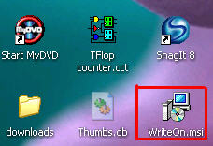
Figure 1: Installer for WriteOn (WriteOn.msi)
Checking for the latest version
You can check for the latest version number of WriteOn from the Title of the main form which is seen when you start WriteOn . The latest version is 0.961.
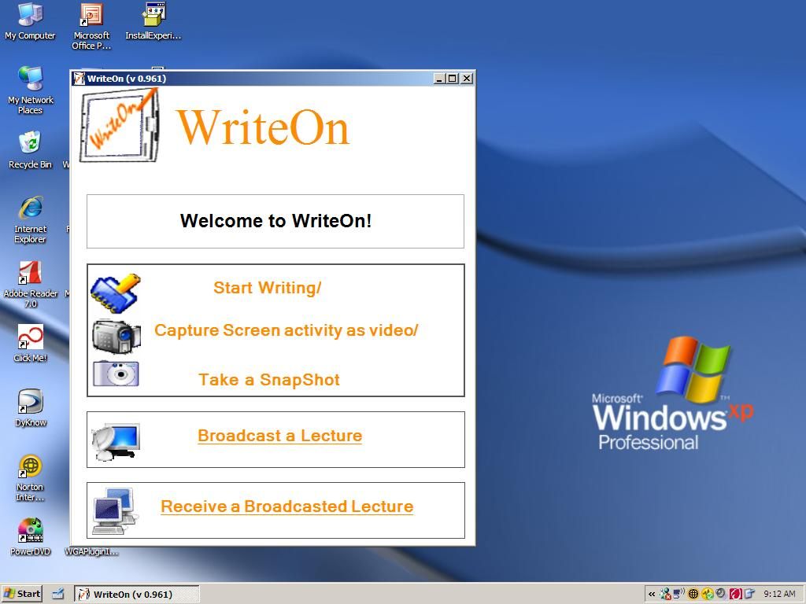

Alternately, one can find the version number by clicking the Information Icon on the task bar of WriteOn as shown below. I shall explain how to get to get to the taskbar shortly.

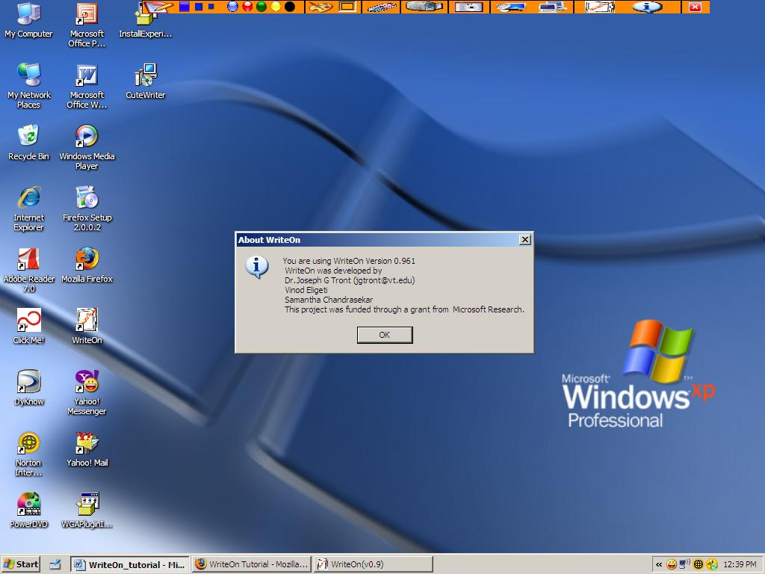

Getting Started
Starting up WriteOn: You can start the WriteOn application by double clicking the WriteOn icon on the desktop (shown below), by choosing to run WriteOn from the Start Menu, or by clicking on the WriteOn.exe file name in the Program Files directory under My Computer.
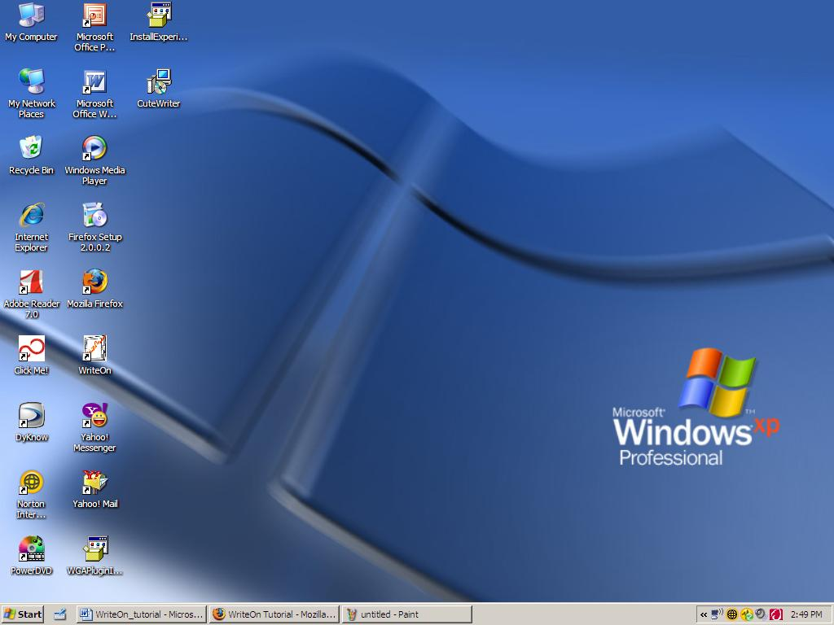
Upon clicking WriteOn icon, the Main Form appears as below:
Annotating with Ink: If the instructor or student wishes to annotate on the lecture slides/notes or an operational program, he/she can do so by selecting the “Start Writing/Capture Screen activity as video/Take Snapshot” button on the main form. The reason that these three tasks are grouped under one button is that all of them take you to the same task bar as shown below.
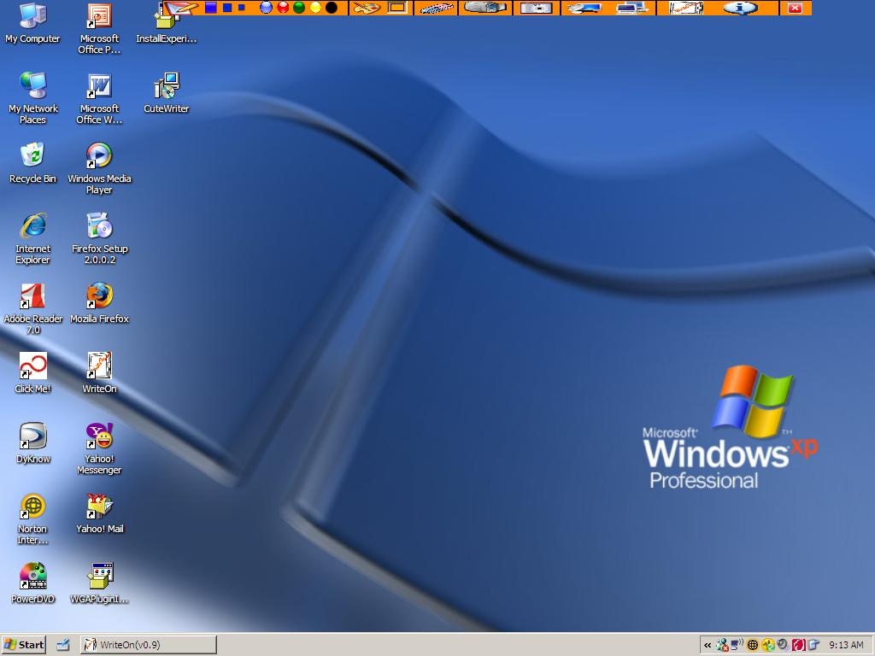

This mode is called “Vellum Mode”. This WriteOn taskbar provides an array of options from setting the ink color and width to performing other tasks like taking a snapshot or receiving or broadcasting a lecture.
Let’s begin by first taking a look at how to start annotating with ink. The first button on the task bar on your extreme left is the icon used to bring up the virtual transparency on which the user will start writing. Upon moving your mouse over a tool tip comes up as shown below:
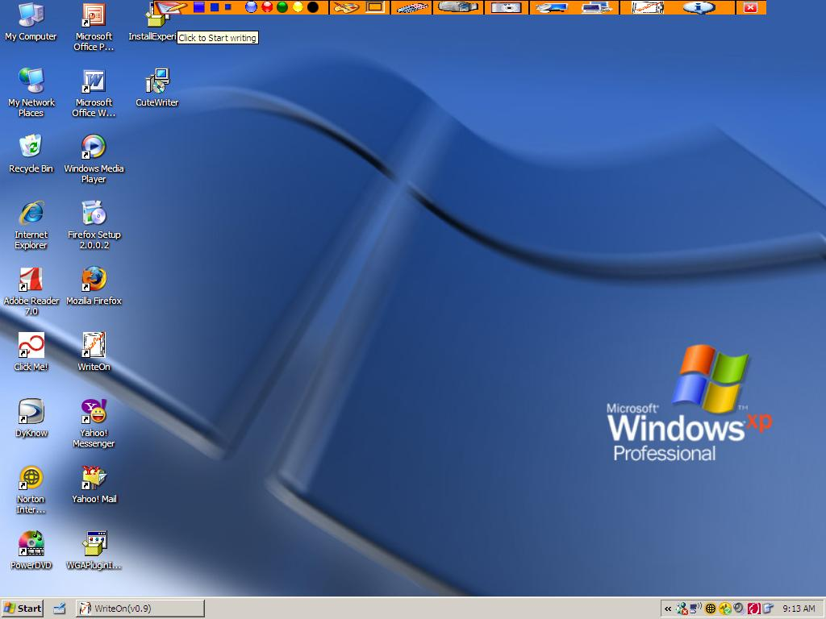

Upon clicking this “Start Writing” button, cause a slight flash in the screen after which a transparent vellum is placed on the screen. The user may now annotate on the screen and save the annotations as a screen shot or may choose to capture all screen activity as a movie for later replay. A screen shot with the vellum in place and ink annotations added is shown below:
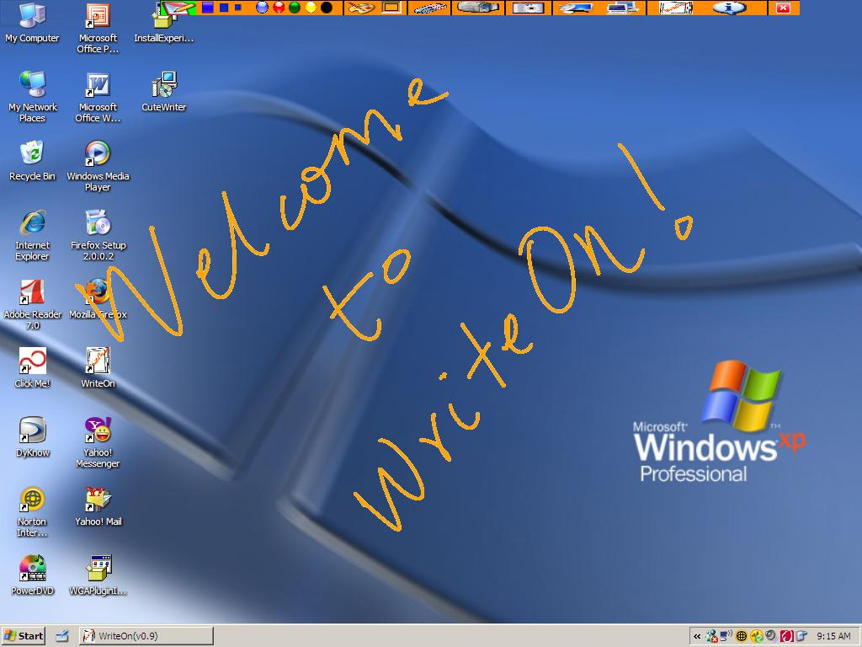
As one can see the “start writing” icon has been highlighted to lime green to indicate that you are in “writing mode”.
The default pen color is Orange. The width of the pen can be changed by clicking on any of the three width indicator buttons below.

The color of the pen can be changed to any of the common primary colors by clicking on any of the color five color bubbles. The picture below shows the ink color changed to Blue.

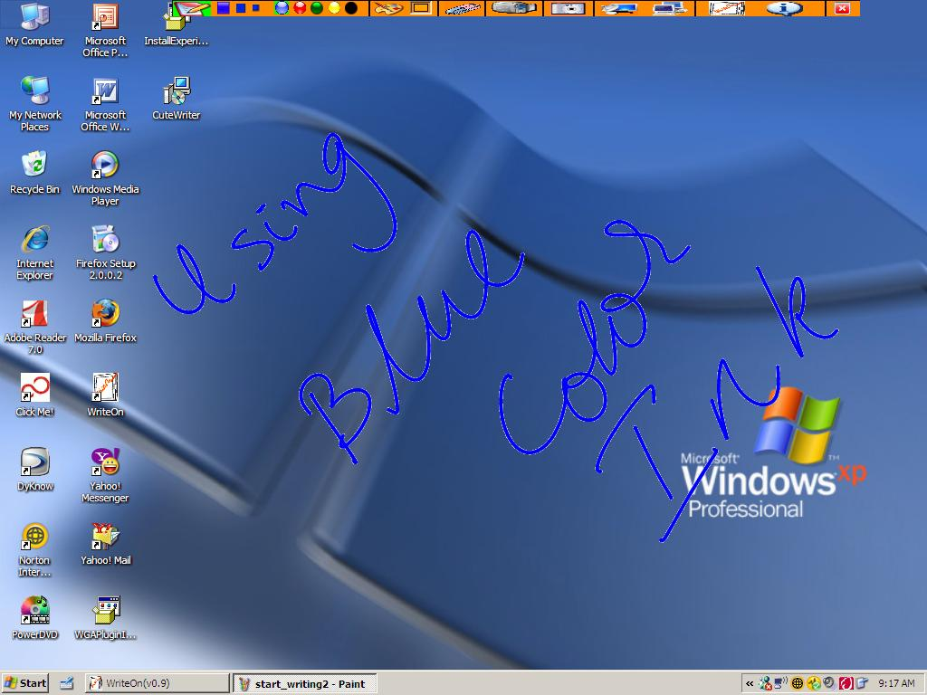

A custom color can be chosen by clicking on the “paint palette”. This brings up a “choose color dialog” from which you can select a custom color of your choice. The color dialog is as bellow:
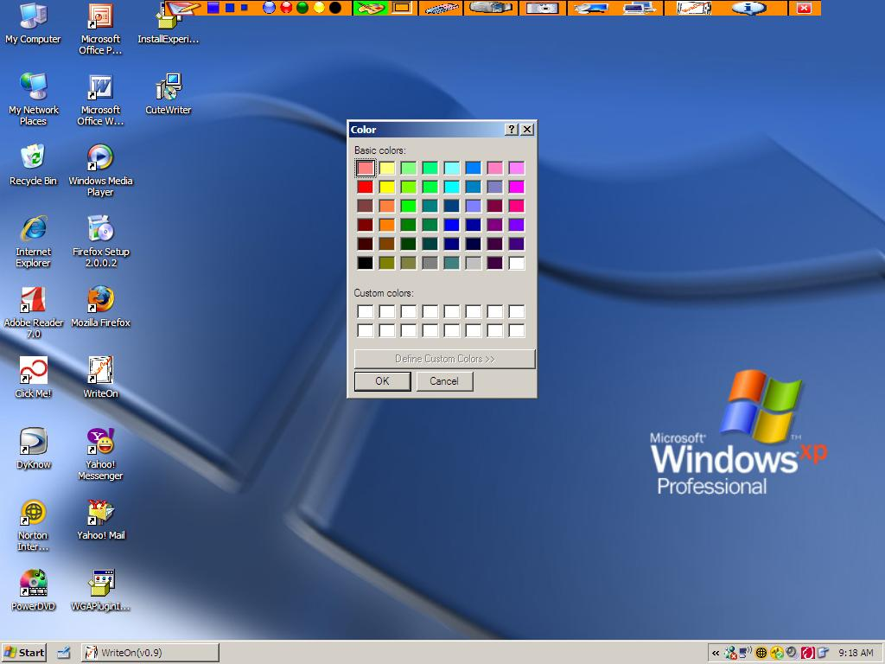

The chosen color appears in the box beside the color palette icon with its back ground highlighted to indicate that you have chosen a custom color. In our example, we choose the first color in the grid.

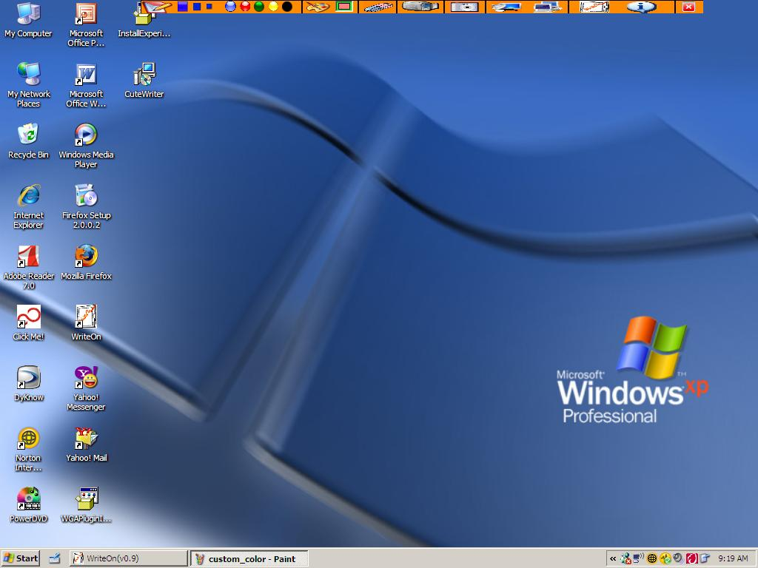

Stop Writing/Toggle Vellum: To “toggle” the vellum and access the desktop, one can use the “Alt + F2” key or click back on the “Start Writing” button. The vellum may be alternately added or removed by pressing the “Alt+F2” key.

Erase Ink : The eraser button allows you to erase all of the ink on the vellum. One can also use the shortcut keystroke “Alt +F3” to achieve the same effect. To erase only parts of the ink annotation, the user can use the back of the stylus.
Begin Capture: The user can start to capture the current desktop screen action by clicking on the video camera picture box/button. The screen movie can also be broadcast across to the students from the instructor’s machine (see Broadcasting). Snapshots of how to start capturing are shown below.
A save as dialog pops up and one can save the lecture as a .wmv file in any file location of his/her choice. Once, the user click “OK” in the save file dialog, the screen capture starts.
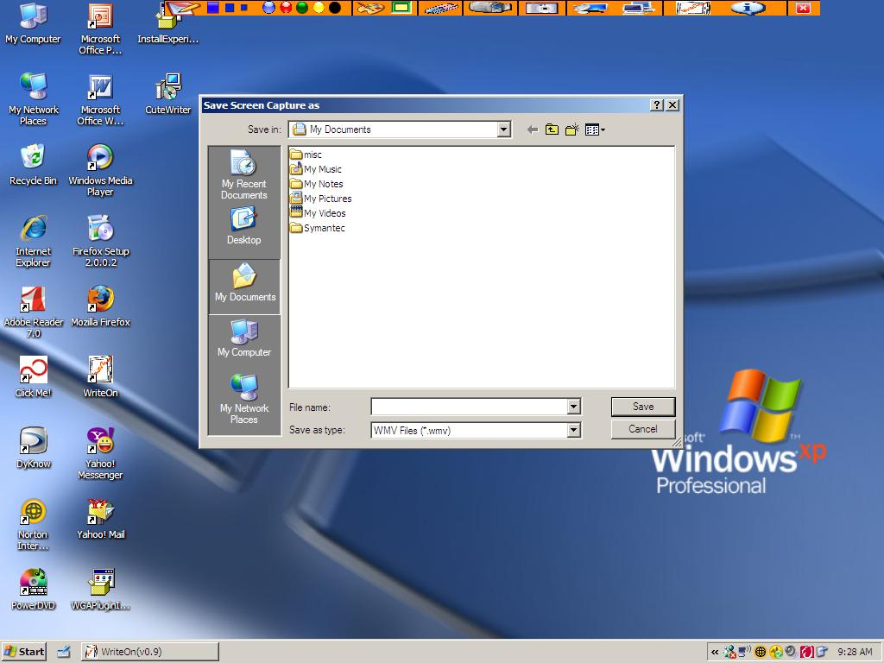

Once the screen capture starts, the video camera picture box gets highlighted to indicate that a screen capture is underway.

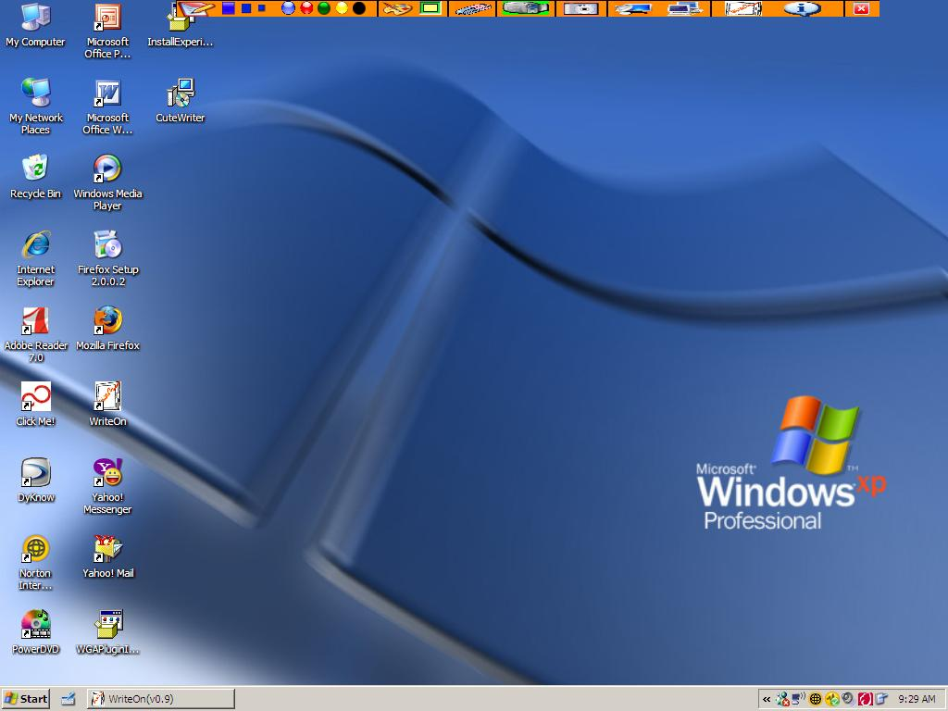

Taking a Snapshot: If you wish to take a snapshot of the screen, you can do so by clicking the camera picture icon in the buttons menu (see below). .An image of the screen will be saved as a .JPG file in any directory the user chooses. The default name of the picture will be the system date followed by the words “Lecture Slide” followed by a sequence number. In this way the user need not to repeatedly enter a filename for each capture. The user typically enters a new directory for each set of screen captures that relate to a specific lecture topic and in this way all relevant screen captures are placed in the same directory.

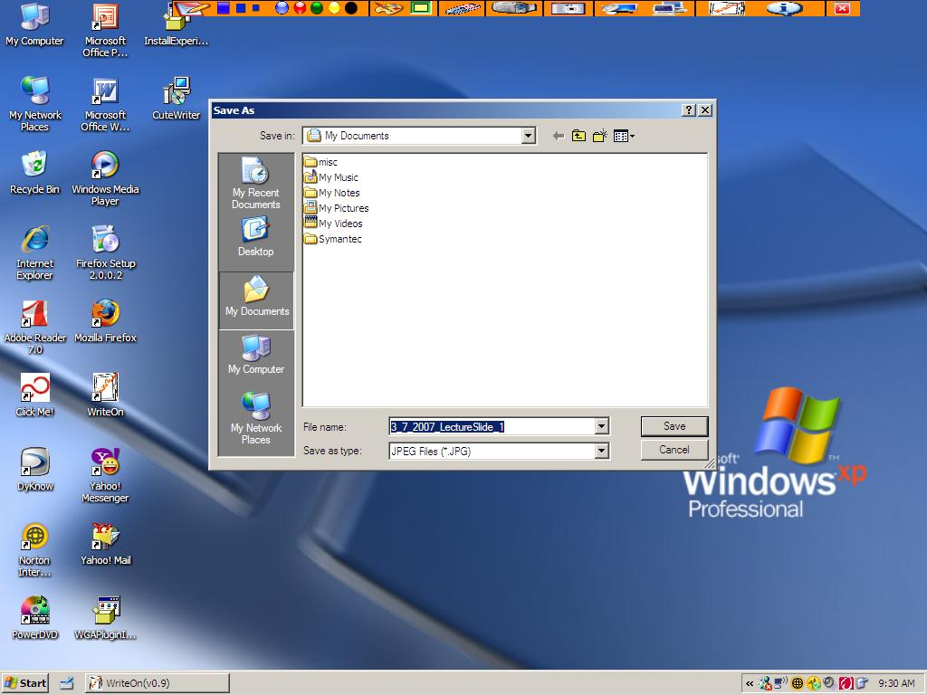

Broadcasting a Lecture: An instructor can broadcast the lecture slides to a class by connecting to the multicast venue. The students MUST also connect to the same venue. The figures below demonstrate the steps needed to begin the broadcasting operation.

The user can choose to broadcast from the Main form, the form shown at startup of the program, by clicking on the “Broadcast a Lecture button” as show below.

This click brings up a Broadcast Lecture dialog box as shown below. This dialog box contains the default name of your computer (Computer Name in the My Computer Properties dialogue) as shown in the textbox labeled Name. By editing the Name textbox, one can choose to provide a different name under which the computer will connect to the multicast session. Below the Name field is a list of the multicast venue IP addresses. The user must choose one of the venues to begin the multicast network session.

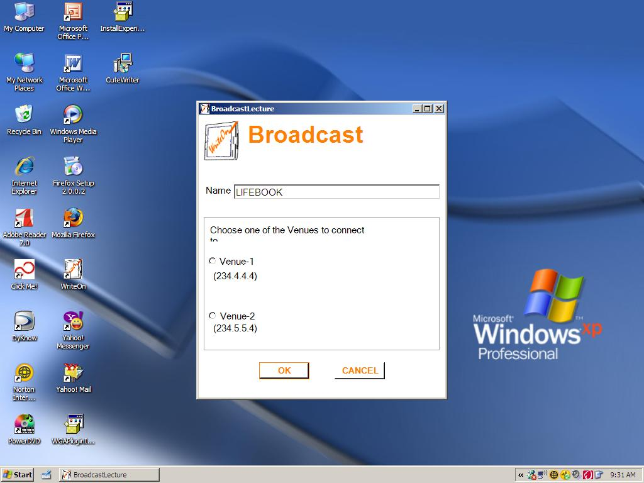

Once a venue is chosen, in this example Venue 1, and OK is clicked, you see the title of the form changed to the below. If you cannot connect to the venue because of network difficulties, an error message will be shown.

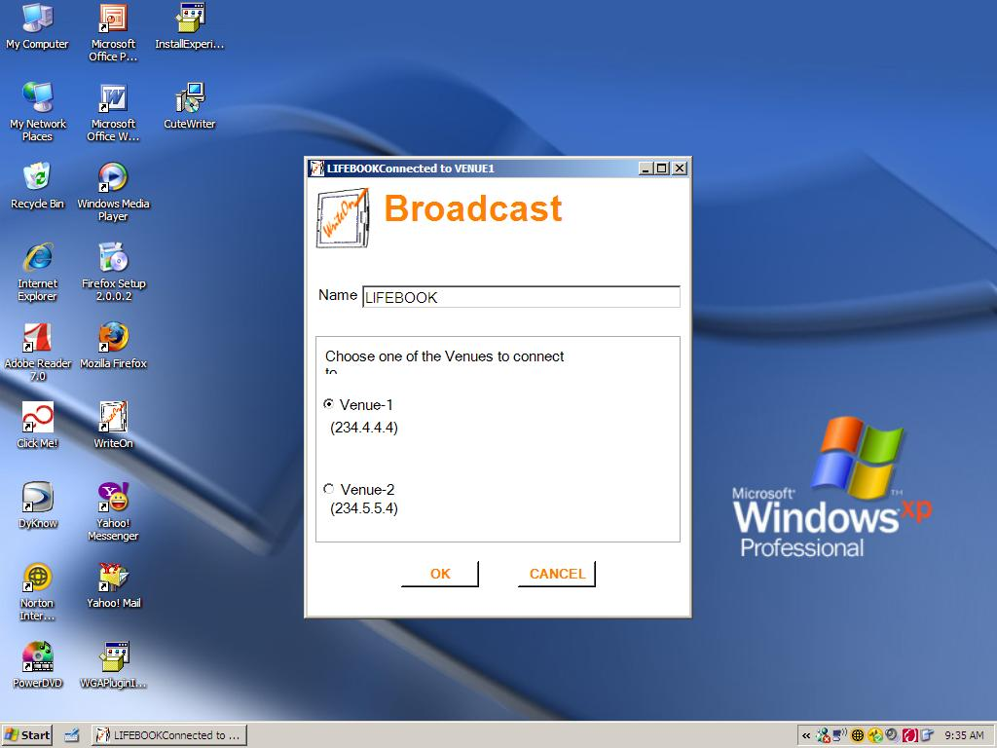

If you do not choose a venue and click OK, an error message appears as below:

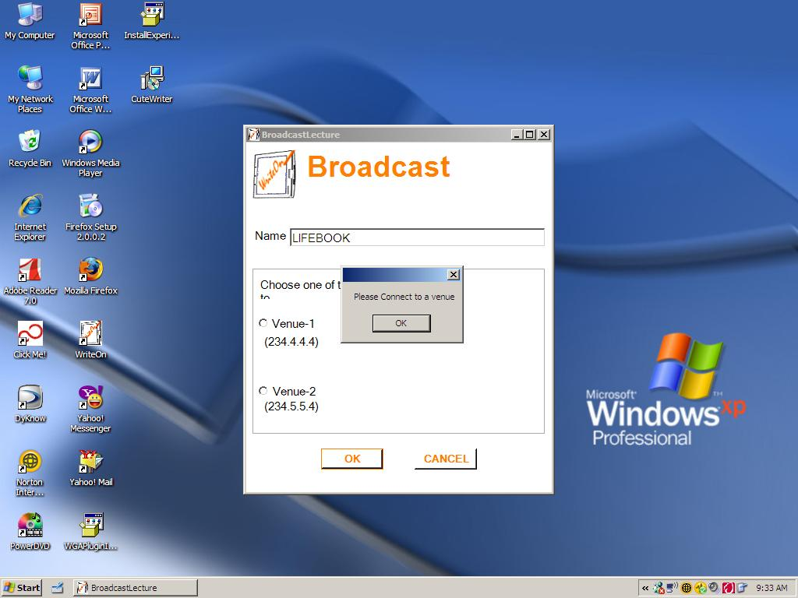

If you have successfully connected to the venue, the broadcast dialog disappears and you are taken to the “vellum mode” and you see the broadcast lecture picture box highlighted to indicate you are broadcasting as shown below.

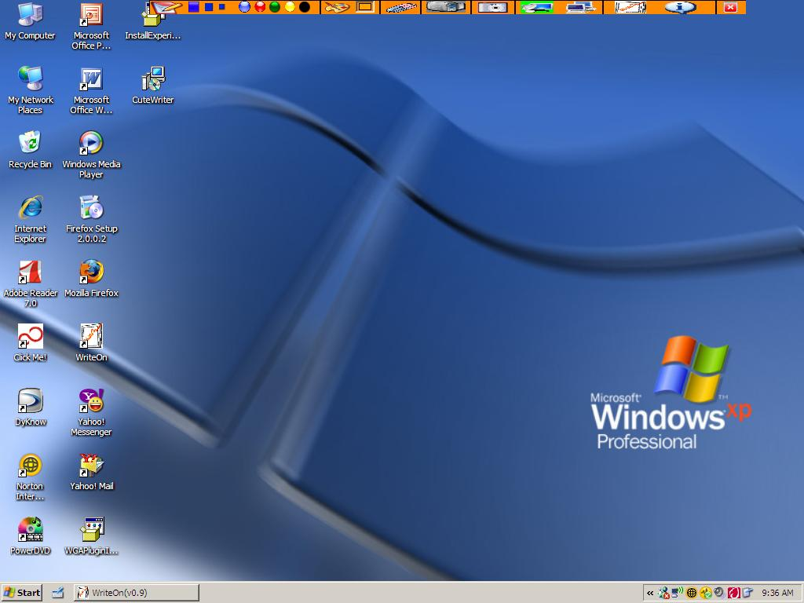

Alternately, the user can begin a broadcast from the “vellum mode” by clicking on the broadcast button in the task bar as shown below. The same venue selection procedure as above will be followed.

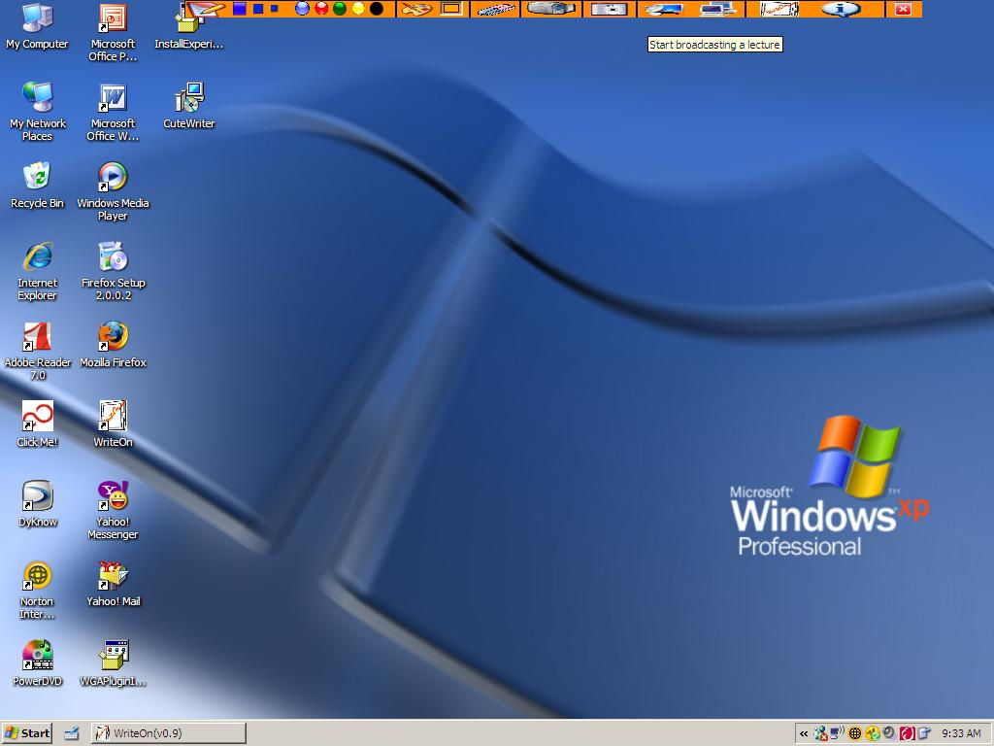

Stop Broadcast: If the user wishes to stop broadcasting the lecture, he/she can do so by clicking on the highlighted broadcast lecture icon. A message box will pop up requesting confirmation that the user would like to disconnect from the venue and stop broadcasting. (see below).

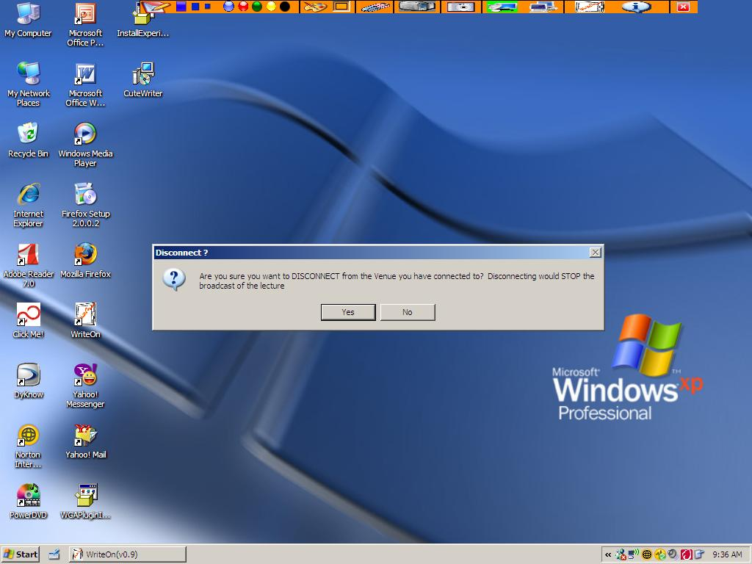

Receive Lecture: The student client machine can receive the lecture slides in a class in real-time by connecting to the multicast venue. The students MUST connect to the same venue as the instructor. The snapshots below demonstrate the steps to begin receiving the instructor’s movie broadcast. One can choose to receive the broadcast from the Main form by clicking on the “Receive a Broadcasted Lecture” button as show below.

Clicking the button will bring up a Receive Lecture dialog box. This dialog box contains the name of your client computer as show in the Name dialogue box. It list the multicast venues IP addresses. You have to choose from either venue to begin receiving a broadcast.

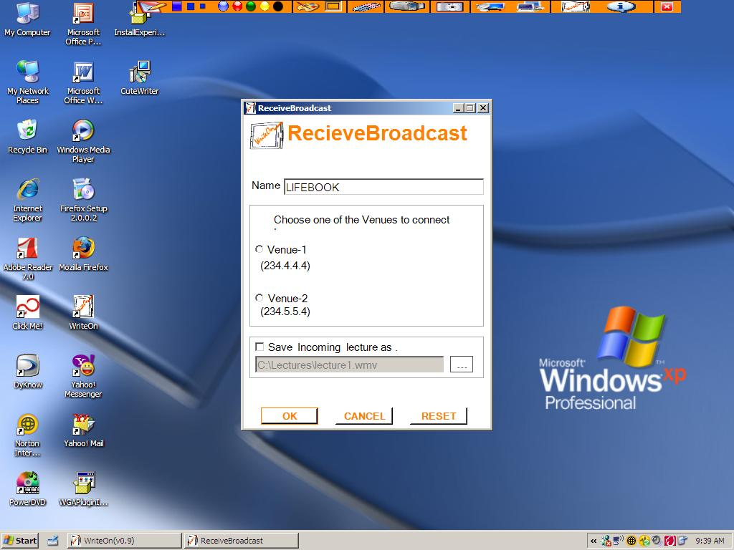

As in the case of the broadcast lecture, the user has to connect to a venue before clicking “OK” otherwise an error message will appear. The student client can choose to save the lecture by clicking on the “Save Incoming lecture as” check box shown above which will produce the dialogue box shown below.

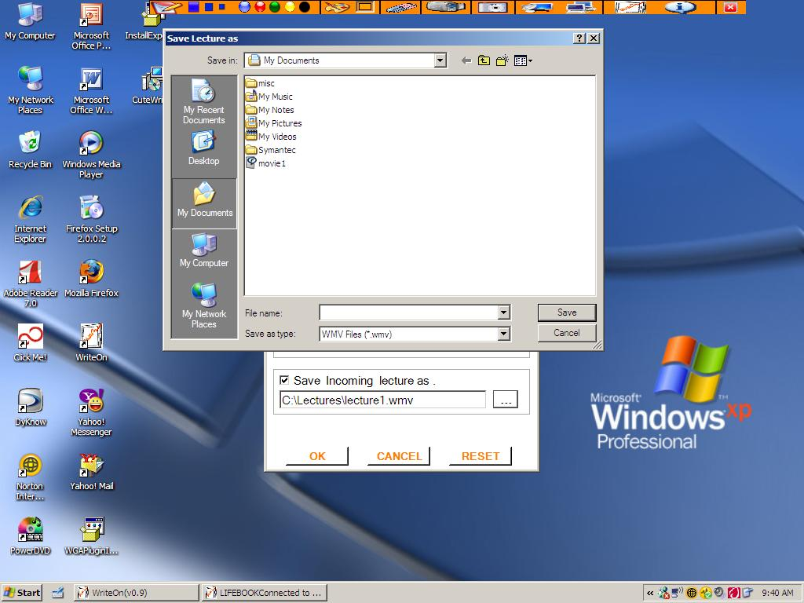
Once the user clicks OK on the receive dialog box, the dialog box disappears and the receive broadcast icon is highlighted to indicate that the use is receiving a lecture broadcast. (See below).
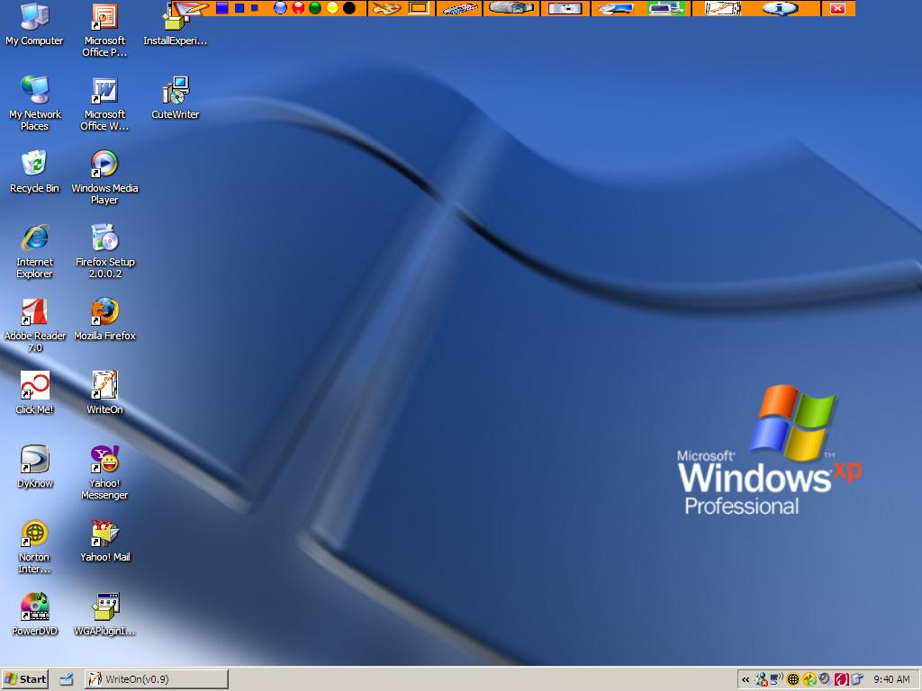
The client user can also initiate receiving a broadcast from the “vellum mode” by clicking on the receive lecture icon which is circled in the menu below. The same setup and dialogue steps described above must then be followed.
The user can stop receiving a broadcast by clicking on the highlighted receive lecture picture box.
Exiting from WriteOn: The user can exit from WriteOn by clicking on the (X) in the upper right corner of the main form seen at startup or on the (X) in the menu bar.
Notice that during the movie capture and broadcast modes, WriteOn sets the Graphics Hardware Acceleration to None. Upon normal termination the Graphics Hardware Acceleration is set back to its original state (generally Full acceleration). If WriteOn is terminated abnormally, the Graphics Hardware Acceleration may need to be set manually.

